Optical Character Recognition System for English Language

A project-report submitted in partial fulfillment for the degree
of

B. Tech in Computer Science and Engineering
of
Maulana Abul Kalam Azad University of Technology

Under the supervision of

Dr. Srikanta Pal

Submitted by

Abhijeet Kumar Kushwaha

Roll No. 24100115001 Regn. No.: 152410110001 of 2015-16
Anik Das

Roll No. 24100115006 Regn. No.: 152410110006 of 2015-16
Debaproto Mukherjee

Roll No. 24100115018 Regn. No.: 152410110018 of 2015-16
Sayani Chakraborty

Roll No. 24100115043 Regn. No.: 152410110043 of 2015-16
Sujash Saha

Roll No. 24100115051 Regn. No.: 152410110051 of 2015-16

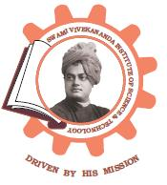

Department of Computer Science & Engineering
Swami Vivekananda Institute of Science & Technology
Dakshin Gobindapur. P.S.: Sonarpur
Kolkata – 700 145

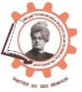
Swami Vivekananda Institute of Science & Technology
Dakshin Gobindapur. P.S.: Sonarpur. Kolkata – 700145.

CERTIFICATE

This is to certify that the project work, entitled “Optical Character Recognition and Speech” submitted by Abhijeet Kumar Kushwaha, Anik Das, Debaproto Mukherjee,

Sujash Saha, Sayani Chakraborty has been prepared according to the regulation of the degree B. Tech in Computer Science and Engineering of the West Bengal University of Technology. The candidate(s) have partially fulfilled the requirements for the submission of the project work.

---------------------------------------- ----------------------------------------
(Signature of HOD) (Signature of the Supervisor)
Deptt. of Computer Sc. & Engg. Deptt. of Computer Sc. & Engg.

----------------------------------------------
(Signature of External Examiner)

ACKNOWLEDGEMENTS

It is a great pleasure for me to express my earnest and great appreciation to Dr. Srikanta Pal, my project guide. I am very much grateful to him for his kind guidance, encouragement, valuable suggestions, innovative ideas, and supervision throughout this project work, without which the completion of the project work would have been difficult one.

I would like to express my thanks to Head of the Department, Mr. Pranab Gayen for his active support.

I also express my sincere thanks to all the teachers of the department for their precious help, encouragement, kind cooperation and suggestions throughout the development of the project work.

I would like to express my gratitude to the library staffs and laboratory staffs for providing me with a congenial working environment.

Date:-------------------------------------------
(Full Signature of the Student(s))
B. Tech in Comp. Sc. & Engg.
Department of Computer Science& Engg.
Swami Vivekananda Institute of Science & Technology

CONTENTS
⎯⎯⎯⎯⎯⎯⎯⎯⎯⎯⎯⎯⎯⎯⎯⎯⎯⎯⎯⎯⎯⎯⎯⎯⎯⎯⎯⎯⎯

Topics Page No.

1) Certificate 2

2) Acknowledgments 3

3) Abstract 5

4) Introduction 6

5) Software 7 - 19
a) Tesseract OCR Engine 7
b) Python Text to Speech Software 16
c) Python 19

6) Code 21

7) Experiment 22

8) Errors 24

9) Result Analysis 28

10) Conclusion 29

11) References 30

ABSTRACT

In the running world, there is growing demand for the software systems to recognize characters in computer system when information is scanned through paper documents as we know that we have number of newspapers and books which are in printed format related to different subjects.
These days there is also a huge demand in storing the information available in these paper documents in to a computer storage disk and then later reusing this information by searching process. One simple way to store information in these paper documents in to computer system is to first scan the documents and then store them as editable text. Optical character recognition is the only process by which printed characters are identified through the use of imaging devices and computer software and it can achieve the goal to read the recognized text for the blind people. Our project aimed to deal with Optical Character Recognizer (OCR), by which printed text can be recognized and make a speech sound for the blind people.

INTRODUCTION

Optical character recognition ( OCR) is the mechanical or electronic conversion of images of typed, handwritten or printed text into machine-encoded text, whether from a scanned document, a photo of a document, a scene-photo (for example the text on signs and billboards in a landscape photo) or from subtitle text superimposed on an image (for example from a television broadcast).

Widely used as a form of information entry from printed paper data records – whether passport documents, invoices, bank statements, computerised receipts, business cards, mail, printouts of static-data, or any suitable documentation – it is a common method of digitising printed texts so that they can be electronically edited, searched, stored more compactly, displayed on-line, and used in machine processes such as cognitive computing, machine translation, (extracted) text-to-speech, key data and text mining. OCR is a field of research in pattern recognition, artificial intelligence and computer vision.

In 1974, Ray Kurzweil started the company Kurzweil Computer Products, Inc. and continued development of omni-font OCR, which could recognize text printed in virtually any font (Kurzweil is often credited with inventing Omni-font OCR, but it was in use by companies, including CompuScan, in the late 1960s and 1970s. Kurzweil decided that the best application of this technology would be to create a reading machine for the blind, which would allow blind people to have a computer read text to them out loud. This device required the invention of two enabling technologies – the CCD flatbed scanner and the text-to-speech synthesizer. On January 13, 1976, the successful finished product was unveiled during a widely reported news conference headed by Kurzweil and the leaders of the National Federation of the Blind. In 1978, Kurzweil Computer Products began selling a commercial version of the optical character recognition computer program. LexisNexis was one of the first customers, and bought the program to upload legal paper and news documents onto its nascent online databases. Two years later, Kurzweil sold his company to Xerox, which had an interest in further commercializing paper-to-computer text conversion. Xerox eventually spun it off as Scan soft which merged with Nuance Communications. The research group headed by A. G. Ramakrishnan at the Medical intelligence and language engineering lab, Indian Institute of Science, has developed PrintToBraille tool, an open source GUI frontend that can be used by any OCR to convert scanned images of printed books to Braille books.

Our aim is to scan a document to recognize it and make it audible to blind persons.

SOFTWARE

1 Tesseract OCR Engine

1.1 Overview of Tesseract OCR

Tesseract is an open-source OCR engine that was developed at HP between 1984 and 1994. Tesseract began as a PhD research project in HP Labs, Bristol, and gained momentum as a possible software and/or hardware add-on for HP’s line of flatbed scanners. Motivation was provided by the fact that the commercial OCR engines of the day were in their infancy, and failed miserably on anything but the best quality print.

1.2 Architecture

Since HP had independently-developed page layout analysis technology that was used in products, (and therefore not released for open-source) Tesseract never needed its own page layout analysis. Tesseract therefore assumes that its input is a binary image with optional polygonal text regions defined. Processing follows a traditional step-by-step pipeline, but some of the stages were unusual in their day, and possibly remain so even now. The first step is a connected component analysis in which outlines of the components are stored. This was a computationally expensive design decision at the time, but had a significant advantage: by inspection of the nesting of outlines, and the number of child and grandchild outlines, it is simple to detect inverse text and recognize it as easily as black-on-white text. Tesseract was probably the first OCR engine able to handle white-on-black text so trivially. At this stage, outlines are gathered together, purely by nesting, into Blobs. Blobs are organized into text lines, and the lines and regions are analyzed for fixed pitch or proportional text. Text lines are broken into words differently according to the kind of character spacing. Fixed pitch text is chopped immediately by character cells. Proportional text is broken into words using definite spaces and fuzzy spaces. Recognition then proceeds as a two-pass process. In the first pass, an attempt is made to recognize each word in turn. Each word that is satisfactory is passed to an adaptive classifier as training data. The adaptive classifier then gets a chance to more accurately recognize text lower down the page Since the adaptive classifier may have learned something useful too late to make a contribution near the top of the page, a second pass is run over the page, in which words that were not recognized well enough are recognized again. A final phase resolves fuzzy spaces, and checks alternative hypotheses for the x-height to locate smallcap text.

1.3 Line and Word Finding

1.3.1 Line Finding

The line finding algorithm is one of the few parts of Tesseract . The line finding algorithm is designed so that a skewed page can be recognized without having to de-skew, thus saving loss of image quality. The key parts of the process are blob filtering and line construction. Assuming that page layout analysis has already provided text regions of a roughly uniform text size, a simple percentile height filter removes drop-caps and vertically touching characters. The median height approximates the text size in the region, so it is safe to filter out blobs that are smaller than some fraction of the median height, being most likely punctuation, diacritical marks and noise. The filtered blobs are more likely to fit a model of non-overlapping, parallel, but sloping lines. Sorting and processing the blobs by x-coordinate makes it possible to assign blobs to a unique text line, while tracking the slope across the page, with greatly reduced danger of assigning to an incorrect text line in the presence of skew. Once the filtered blobs have been assigned to lines, a least median of squares fit is used to estimate the baselines, and the filtered-out blobs are fitted back into the appropriate lines. The final step of the line creation process merges blobs that overlap by at least half horizontally, putting diacritical marks together with the correct base and correctly associating parts of some broken characters.

1.3.2 Baseline Fitting

Once the text lines have been found, the baselines are fitted more precisely using a quadratic spline. This was another first for an OCR system, and enabled Tesseract to handle pages with curved baselines, which are a common artifact in scanning, and not just at book bindings. The baselines are fitted by partitioning the blobs into groups with a reasonably continuous displacement for the original straight baseline. A quadratic spline is fitted to the most populous partition, (assumed to be the baseline) by a least squares fit. The quadratic spline has the advantage that this calculation is reasonably stable, but the disadvantage that discontinuities can
arise when multiple spline segments are required.

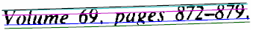
Fig. 1. An example of a curved fitted baseline.

Fig.1 shows an example of a line of text with a fitted baseline, descender line, meanline and ascender line. All these lines are “parallel” (the y separation is a constant over the entire length) and slightly curved. The ascender line is cyan (prints as light gray) and the black line above it is actually straight. Close inspection shows that the cyan/gray line is curved relative to the straight black line above it.

1.3.3 Fixed Pitch Detection and Chopping

Tesseract tests the text lines to determine whether they are fixed pitch. Where it finds fixed pitch text, Tesseract chops the words into characters using the pitch, and disables the chopper and associator on these words for the word recognition step. Fig. 2 shows a typical example of a fixed-pitch word.

Fig. 2. A fixed-pitch chopped word.

1.3.4 Proportional Word Finding

Non-fixed-pitch or proportional text spacing is a highly non-trivial task. Fig. 3 illustrates some typical problems. The gap between the tens and units of ‘11.9%’ is a similar size to the general space, and is certainly larger than the kerned space between ‘erated’ and ‘junk’. There is no horizontal gap at all between the bounding boxes of ‘of’ and ‘financial’. Tesseract solves most of these problems by measuring gaps in a limited vertical range between the baseline and meanline. Spaces that are close to the threshold at this stage are made fuzzy, so that a final decision can be made after word recognition.

Fig. 3. Some difficult word spacing.

1.4 Word Recognition

Part of the recognition process for any character recognition engine is to identify how a word should be segmented into characters. The initial segmentation output from line finding is classified first. The rest of the word recognition step applies only to non-fixed pitch text.

1.4.1 Chopping Joined Characters

While the result from a word is unsatisfactory, Tesseract attempts to improve the result by chopping the blob with worst confidence from the character classifier. Candidate chop points are found from concave vertices of a polygonal approximation of the outline, and may have either another concave vertex opposite, or a line segment. It may take up to 3 pairs of chop points to successfully separate joined characters from the ASCII set.

Fig. 4. Candidate chop points and chop.

Fig. 4 shows a set of candidate chop points with arrows and the selected chop as a line across the
outline where the ‘r’ touches the ‘m’. Chops are executed in priority order. Any chop that fails to improve the confidence of the result is undone, but not completely discarded so that the chop can be re-used later by the associator if needed.

1.4.2 Associating Broken Characters

When the potential chops have been exhausted, if the word is still not good enough, it is given to the associator. The associator makes an A* (best first) search of the segmentation graph of possible combinations of the maximally chopped blobs into candidate characters. It does this without actually building the segmentation graph, but instead maintains a hash table of visited states. The A* search proceeds by pulling candidate new states from a priority queue and evaluating them by classifying unclassified combinations of fragments. It may be argued that this fully-chop-then-associate approach is at best inefficient, at worst liable to miss important chops, and that may well be the case. The advantage is that the chop-then-associate scheme simplifies the data structures that would be required to maintain the full segmentation graph.
Fig. 5. An easily recognized word.

Tesseract’s accuracy on broken characters was well ahead of the commercial engines of the day. Fig. 5 is a typical example. An essential part of that success was the character classifier that could easily recognize broken characters.

1.5 Static Character Classifier

1.5.1 Features

An early version of Tesseract used topological features developed from the work of Shillman et. Al [7]. Though nicely independent of font and size, these features are not robust to the problems found in real life images, as Bokser describes. An intermediate idea involved the use of segments of the polygonal approximation as features, but this approach is also not robust to damaged characters. For example, in Fig. 6(a), the right side of the shaft is in two main pieces, but in Fig. 6(b) there is just a single piece.

Fig. 6. (a) Pristine ‘h, (b) broken ‘h’, (c) features matched to prototypes.

The breakthrough solution is the idea that the features in the unknown need not be the same as the features in the training data. During training, the segments of a polygonal approximation are used for features, but in recognition, features of a small, fixed length (in normalized units) are extracted from the outline and matched many-to-one against the clustered prototype features of the training data. In Fig. 6(c), the short, thick lines are the features extracted from the unknown, and the thin, longer lines are the clustered segments of the polygonal approximation that are used as prototypes. One prototype bridging the two pieces is completely unmatched. Three features on one side and two on the other are unmatched, but, apart from those, every prototype and every feature is well matched.
This example shows that this process of small features matching large prototypes is easily able to cope with recognition of damaged images. Its main problem is that the computational cost of computing the distance between an unknown and a prototype is very high.
The features extracted from the unknown are thus 3- dimensional, (x, y position, angle), with typically 50- 100 features in a character, and the prototype features are 4-dimensional (x, y, position, angle, length), with typically 10-20 features in a prototype configuration.

1.5.2 Classification

Classification proceeds as a two-step process. In the first step, a class pruner creates a shortlist of character classes that the unknown might match. Each feature fetches, from a coarsely quantized 3-dimensional lookup table, a bit-vector of classes that it might match, and the bit-vectors are summed over all the features. The classes with the highest counts (after correcting for expected number of features) become the short-list for the next step. Each feature of the unknown looks up a bit vector of prototypes of the given class that it might match, and then the actual similarity between them is computed. Each prototype character class is represented by a logical sum-of-product expression with each term called a configuration, so the distance calculation process keeps a record of the total similarity evidence of each feature in each configuration, as well as of each prototype. The best combined distance, which is calculated from the summed feature and prototype evidences, is the best over all the stored configurations of the class.

1.5.3 Training Data

Since the classifier is able to recognize damaged characters easily, the classifier was not trained on damaged characters. In fact, the classifier was trained on a mere 20 samples of 94 characters from 8 fonts in a single size, but with 4 attributes (normal, bold, italic, bold italic), making a total of 60160 training samples. This is a significant contrast to other published classifiers, such as the Calera classifier with more than a million samples [9], and Baird’s 100-font classifier [10] with 1175000 training samples.

1.6 Linguistic Analysis

Tesseract contains relatively little linguistic analysis. Whenever the word recognition module is
considering a new segmentation, the linguistic module (mis-named the permuter) chooses the best available word string in each of the following categories: Top frequent word, Top dictionary word, Top numeric word, Top UPPER case word, Top lower case word (with optional initial upper), Top classifier choice word. The final decision for a given segmentation is where each of the above categories is multiplied by a different constant. Words from different segmentations may have different numbers of characters in them. It is hard to compare these words directly, even where a classifier claims to be producing probabilities, which Tesseract does not. This problem is solved in Tesseract by generating two numbers for each character classification. The first, called the confidence, is minus the normalized distance from the prototype. This enables it to be a “confidence” in the sense that greater numbers are better, but still a distance, as, the farther from zero, the greater the distance. The second output, called the rating, multiplies the normalized distance from the prototype by the total outline length in the unknown character. Ratings for characters within a word can be summed meaningfully, since the total outline length for all characters within a word is always the same.

1.7 Adaptive Classifier

It has been suggested [11] and demonstrated [12] that OCR engines can benefit from the use of an adaptive classifier. Since the static classifier has to be good at generalizing to any kind of font, its ability to discriminate between different characters or between characters and non-characters is weakened. A more font-sensitive adaptive classifier that is trained by the output of the static classifier is therefore commonly [13] used to obtain greater discrimination within each document, where the number of fonts is limited. Tesseract does not employ a template classifier, but uses the same features and classifier as the static classifier. The only significant difference between the static classifier and the adaptive classifier, apart from the training data, is that the adaptive classifier uses isotropic baseline/x-height normalization, whereas the static classifier normalizes characters by the centroid (first moments) for position and second moments for anisotropic size normalization. The baseline/x-height normalization makes it easier to distinguish upper and lower case characters as well as improving immunity to noise specks. The main benefit of character moment normalization is removal of font aspect ratio and some degree of font stroke width. It also makes recognition of sub and superscripts simpler, but requires an additional classifier feature to distinguish some upper and lower case characters. Fig. 7 shows an example of 3 letters in baseline/x-height normalized form and moment
normalized form.

Fig. 7. Baseline and moment normalized letters.

1.8 Page layout via tab-stop detection

When a page is laid out, either by a professional publishing system, or by a common word processor, the regions of a page are bounded by tab-stops. The margins, column edges, indentation, and columns of a table are all placed at fixed x-positions at which edges or centers of text lines are aligned vertically. Tab-stops distinguish tables from body text, and they also bound rectangular non-column elements, such as inset images and pull-out quotes. The tab-stops in the example of Fig. 8 are the column boundaries with an additional tab-stop for the paragraph indentation that is not required for finding the page layout. The non-rectangular inset image, typically, strays outside of the column boundaries. In some sense, white rectangles match tab-stops, but white rectangles may be disrupted by background noise or background images. Also the ends of white rectangles do not match the ends of the region bounded by the tab-stops, because the white rectangles run on into the perpendicular whitespace.

Fig.8. Input image.

Fig.9. (a) Vertical lines, (b) Image elements.

Fig.9. Filtered CCs Fig. 10 Cleaned tab-stops.

Fig.11. Typed partition chains. Fig.12. Final blocks.

2 PYTTSX3(PYTHON TEXT TO SPEECH 3)

Supported synthesizers Version 2.6 of pyttsx3 includes drivers for the following text-to-speech synthesizers. Only operating systems on which a driver is tested and known to work are listed. The drivers may work on other systems. • SAPI5 on Windows XP and Windows Vista and Windows 8,8.1 , 10 • NSSpeechSynthesizer on Mac OS X 10.5 (Leopard) and 10.6 (Snow Leopard) • espeak on Ubuntu Desktop Edition 8.10 (Intrepid), 9.04 (Jaunty), and 9.10 (Karmic) The pyttsx3.init() documentation explains how to select a specific synthesizer by name as well as the default for each platform.

An application invokes the pyttsx3.init() factory function to get a reference to a pyttsx3.Engine instance. During construction, the engine initializes a pyttsx3.driver.DriverProxy object responsible for loading a speech engine driver implementation from the pyttsx3.drivers module. After construction, an application uses the engine object to register and unregister event callbacks; produce and stop speech; get and set speech engine properties; and start and stop event loops.

2.1 Examples

2.1.1 Speaking text
import pyttsx3
engine = pyttsx3.init()
engine.say('Sally sells seashells by the seashore.')
engine.say('The quick brown fox jumped over the lazy dog.')
engine.runAndWait()

2.1.2 Listening for events
import pyttsx3
def onStart(name):
print 'starting', name
def onWord(name, location, length):
print 'word', name, location, length
def onEnd(name, completed):
print 'finishing', name, completed
engine = pyttsx3.init()
engine.connect('started-utterance', onStart)
engine.connect('started-word', onWord)
engine.connect('finished-utterance', onEnd)
engine.say('The quick brown fox jumped over the lazy dog.')
engine.runAndWait()

2.1.3 Interrupting an utterance
import pyttsx3
def onWord(name, location, length):
print 'word', name, location, length
if location > 10:
engine.stop()
engine = pyttsx3.init()
engine.connect('started-word', onWord)
engine.say('The quick brown fox jumped over the lazy dog.')
engine.runAndWait()

2.1.4 Changing voices
engine = pyttsx3.init()
voices = engine.getProperty('voices')
for voice in voices:
engine.setProperty('voice', voice.id)
engine.say('The quick brown fox jumped over the lazy dog.')
engine.runAndWait()

2.1.5 Changing speech rate
engine = pyttsx3.init()
rate = engine.getProperty('rate')
engine.setProperty('rate', rate+50)
engine.say('The quick brown fox jumped over the lazy dog.')
engine.runAndWait()

2.1.6 Changing volume
engine = pyttsx3.init()
volume = engine.getProperty('volume')
engine.setProperty('volume', volume-0.25)
engine.say('The quick brown fox jumped over the lazy dog.')
engine.runAndWait()

2.1.7 Running a driver event loop
engine = pyttsx3.init()
def onStart(name):
print 'starting', name
def onWord(name, location, length):
print 'word', name, location, length
def onEnd(name, completed):
print 'finishing', name, completed
if name == 'fox':
engine.say('What a lazy dog!', 'dog')
elif name == 'dog':
engine.endLoop()
engine = pyttsx3.init()
engine.connect('started-utterance', onStart)
engine.connect('started-word', onWord)
engine.connect('finished-utterance', onEnd)
engine.say('The quick brown fox jumped over the lazy dog.', 'fox')
engine.startLoop()

2.1.8 Using an external event loop
engine = pyttsx3.init()
engine.say('The quick brown fox jumped over the lazy dog.', 'fox')
engine.startLoop(False)
# engine.iterate() must be called inside externalLoop()
externalLoop()
engine.endLoop()

3 PYTHON

Python is a popular programming language. It was created by Guido van Rossum, and released in 1991.
It is used for:
- web development (server-side),
- software development,
- mathematics,
- system scripting.

3.1 Why Python?
- Python works on different platforms (Windows, Mac, Linux, Raspberry Pi, etc).
- Python has a simple syntax similar to the English language.
- Python has syntax that allows developers to write programs with fewer lines than some other programming languages.
- Python runs on an interpreter system, meaning that code can be executed as soon as it is written. This means that prototyping can be very quick.
- Python can be treated in a procedural way, an object-orientated way or a functional way.

Python Syntax compared to other programming languages
- Python was designed for readability, and has some similarities to the English language with influence from mathematics.
- Python uses new lines to complete a command, as opposed to other programming languages which often use semicolons or parentheses.
- Python relies on indentation, using whitespace, to define scope; such as the scope of loops, functions and classes. Other programming languages often use curly-brackets for this purpose.


CODE

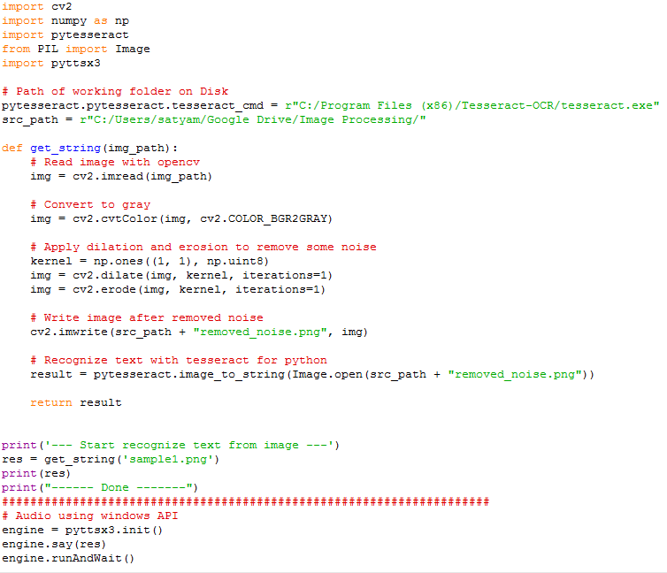

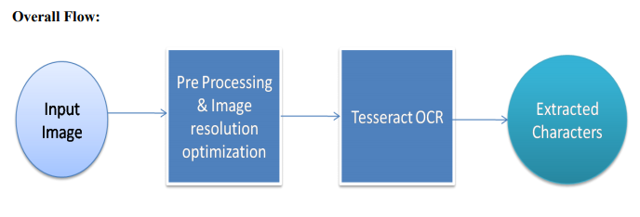
The extracted characters are then converted to audio using PYTTSX3 module.

EXPERIMENT

Experiments have been carried out to evaluate the performance and applicability of the current technique for character recognition on a set of 25 image samples. Few image samples with the corresponding output have been shown here.

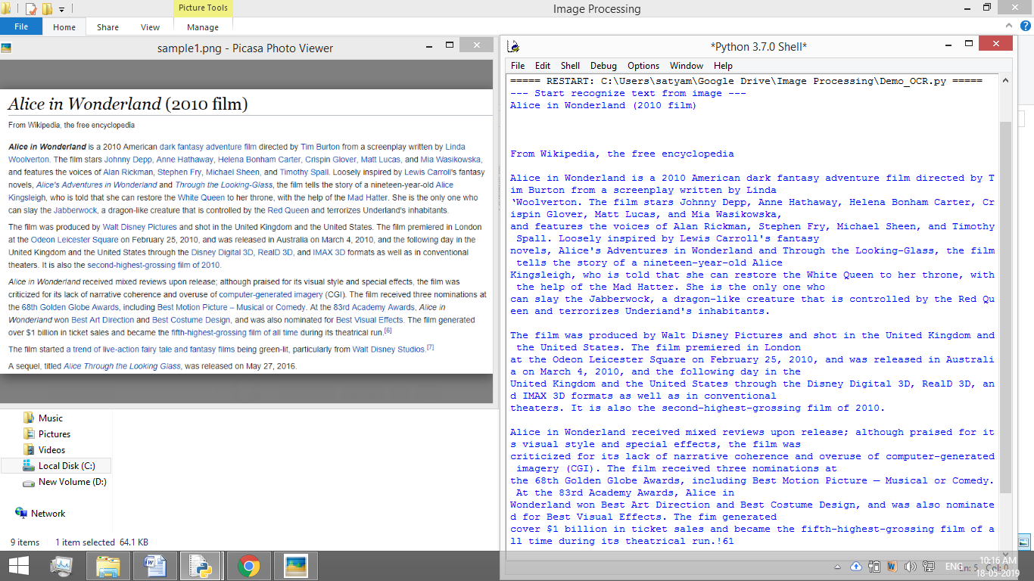

Fig.13. Image sample-1 with output
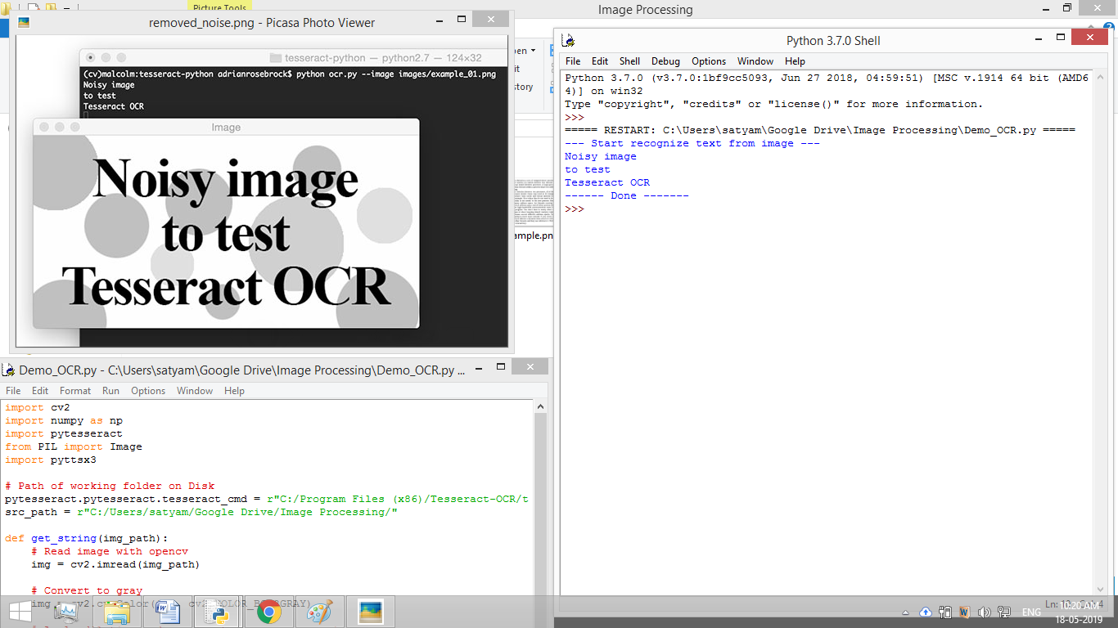

Fig.14. Image sample-2 with output

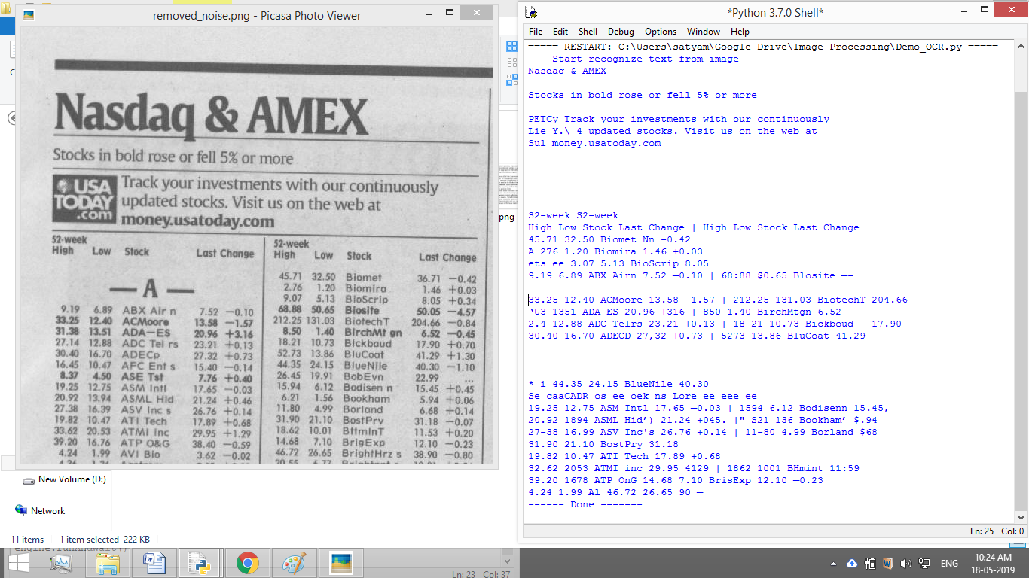

Fig.15. Image sample-3 with output

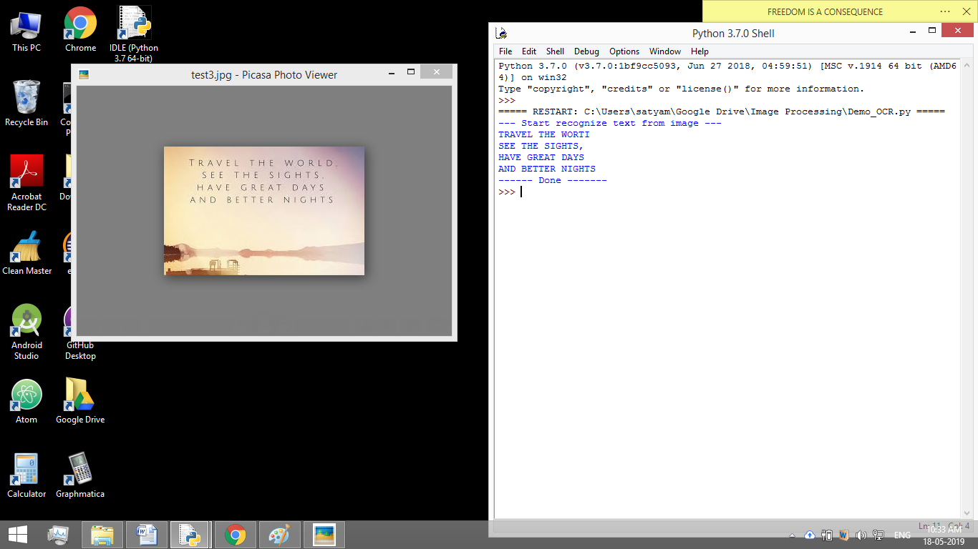

Fig.16. Image sample-4 with output

ERRORS

Our proposed OCR system fails in some image samples and provides some errors. Two image samples with errors are provided below.

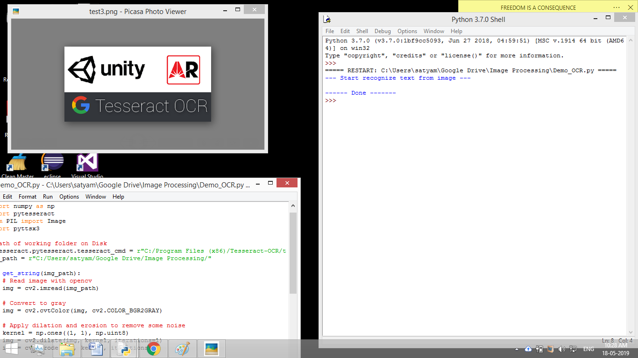

Fig.17. Image sample-1 with error

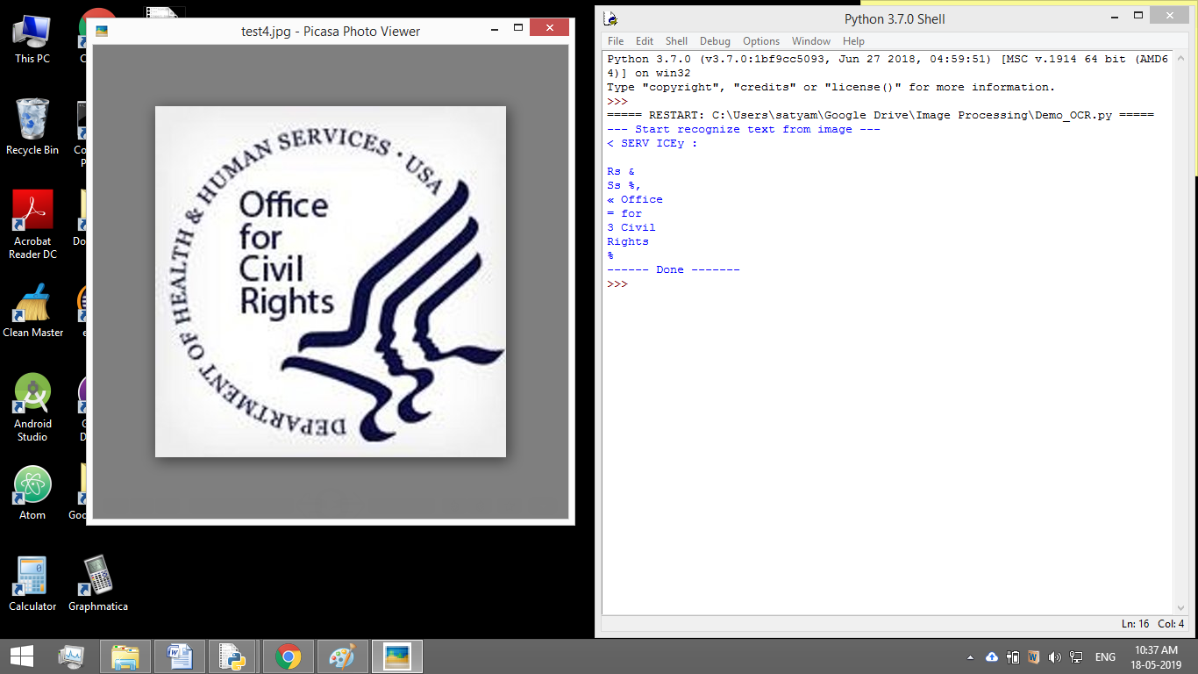

Fig.18. Image sample-2 with error

RESULT ANALYSIS

The code has been tested exhaustively and has been found working on some input image samples quite well and satisfactory results have been achieved. The output is shown in Table1.

Table1: Accuracy with sample numbers

S.L. no | Resolution | Input Image Words | Output Correct Words | Accuracy Percentage | Hyperlink
 | 280x180 | 12 | 11 | 91.67 | Test-Images\Results\res1.png
 | 314x161 | 3 | 0 | 0 | Test-Images\Results\res2.png
 | 400x400 | 10 | 4 | 40 | Test-Images\Results\res3.png
 | 768x340 | 152 | 152 | 100 | Test-Images\Results\res4.png
 | 600x386 | 239 | 239 | 100 | Test-Images\Results\res5.png
 | 600x381 | 6 | 6 | 100 | Test-Images\Results\res6.png
 | 856x494 | 340 | 340 | 100 | Test-Images\Results\res7.png
 | 626x580 | 128 | 201 | 57.03 | Test-Images\Results\res8.png
 | 259x194 | 60 | 60 | 100 | Test-Images\Results\res9.png
 | 225x225 | 1 | 0 | 0 | Test-Images\Results\res10.png
 | 550x332 | 107 | 0 | 0 | Test-Images\Results\res11.png
 | 268x184 | 4 | 4 | 100 | Test-Images\Results\res12.png
 | 977x297 | 34 | 34 | 100 | Test-Images\Results\res13.png
 | 291x173 | 40 | 31 | 77.5 | Test-Images\Results\res14.png
 | 468x423 | 82 | 82 | 100 | Test-Images\Results\res15.png
 | 359x140 | 51 | 51 | 100 | Test-Images\Results\res16.png
 | 850x240 | 56 | 56 | 100 | Test-Images\Results\res17.png
 | 292x172 | 52 | 0 | 0 | Test-Images\Results\res18.png
 | 569x183 | 7 | 7 | 100 | Test-Images\Results\res19.png
 | 259x194 | 70 | 53 | 75.71 | Test-Images\Results\res20.png
 | 376x265 | 20 | 20 | 100 | Test-Images\Results\res21.png
 | 400x533 | 13 | 4 | 30.77 | Test-Images\Results\res22.png
 | 383x132 | 21 | 5 | 23.80 | Test-Images\Results\res23.png
 | 960x720 | 54 | 54 | 100 | Test-Images\Results\res24.png
 | 259x194 | 55 | 50 | 90.91 | Test-Images\Results\res25.png

Here, a sample of 25 random pictures are tested and the average accuracy of 71.5%.is found.

However, for well defined inputs i.e., images with no distortion or pictures, OCR can achieve 100% accuracy.

Tesseract fails for the following cases:

- Handwritten Texts
- Languages other than English
- Blurred texts
- Texts with unusual styling

CONCLUSION

The project can be used for various purposes.

- Converting books to e-books
- Making e-books audible
- OCR in cloud services

Work is being done to implement an Android app which can convert images from camera to text.

OCR is a very useful and popular application. It is being used in a lot of domains currently. The idea of improving and improvising the OCR for regional language text is a very different aspect. India is a country with more than a billion people. Regional language OCR(Hindi, Bengali, Urdu Marathi, etc ) and translation application for mobile phones solves a greater piece of the problem This in turn could be used in various departments such as educational institutions, transport, research and development.

REFERENCES

[1] S.V. Rice, F.R. Jenkins, T.A. Nartker, The Fourth Annual Test of OCR Accuracy, Technical Report 95-03, Information Science Research Institute, University of Nevada, Las Vegas,
July 1995.

[2] R.W. Smith, The Extraction and Recognition of Text from Multimedia Document Images, PhD Thesis, University of Bristol, November 1987.

[3] R. Smith, “A Simple and Efficient Skew Detection Algorithm via Text Row Accumulation”, Proc. of the 3rd Int. Conf. on Document Analysis and Recognition (Vol. 2), IEEE 1995, pp. 1145-1148.

[4] P.J. Rousseeuw, A.M. Leroy, Robust Regression and Outlier Detection, Wiley-IEEE, 2003.

[5] S.V. Rice, G. Nagy, T.A. Nartker, Optical Character Recognition: An Illustrated Guide to the Frontier, Kluwer Academic Publishers, USA 1999, pp. 57-60.

[6] P.J. Schneider, “An Algorithm for Automatically Fitting Digitized Curves”, in A.S. Glassner, Graphics Gems I, Morgan Kaufmann, 1990, pp. 612-626.

[7] R.J. Shillman, Character Recognition Based on Phenomenological Attributes: Theory and Methods, PhD. Thesis, Massachusetts Institute of Technology. 1974.

[8] B.A. Blesser, T.T. Kuklinski, R.J. Shillman, “Empirical Tests for Feature Selection Based on a Pscychological Theory of Character Recognition”, Pattern Recognition 8(2), Elsevier, New York, 1976.

[9] M. Bokser, “Omnidocument Technologies”, Proc. IEEE 80(7), IEEE, USA, Jul 1992, pp. 1066-1078.

[10] H.S. Baird, R. Fossey, “A 100-Font Classifier”, Proc. of the 1st Int. Conf. on Document Analysis and Recognition, IEEE, 1991, pp 332-340.

[11] G. Nagy, “At the frontiers of OCR”, Proc. IEEE 80(7), IEEE, USA, Jul 1992, pp 1093-1100.

[12] G. Nagy, Y. Xu, “Automatic Prototype Extraction for Adaptive OCR”, Proc. of the 4th Int. Conf. on Document Analysis and Recognition, IEEE, Aug 1997, pp 278-282.

[13] I. Marosi, “Industrial OCR approaches: architecture, algorithms and adaptation techniques”, Document Recognition and Retrieval XIV, SPIE Jan 2007, 6500-01.

